SonarQube installation

pre-requesite

Ram size – 2gb
Hard disk – 5gb

sonarqube is a java based Application, so we need to install java

# sudo apt install openjdk-8-jdk -y

Download sonarqube 5.7 version from the web

# wget https://binaries.sonarsource.com/Distribution/sonarqube/sonarqube-5.6.7.zip

# sudo apt install unzip -y

# unzip sonarqube-5.6.7.zip

Sonarqube default database is Mysql, install mysql on your machine

# sudo apt install mysql-server -y

# sudo systemctl start mysql

Login into mysql server, create a database, user & add privileges to that user

# mysql -u username -p

mysql > create database sonar;

mysql > create user'sonar' identified by 'sonar';

mysql > grant all on sonar.* to 'sonar'@'%';

mysql > grant all on sonar.* to 'sonar'@'localhost' identified by 'sonar';

mysql > flush privileges;

mysql > exit

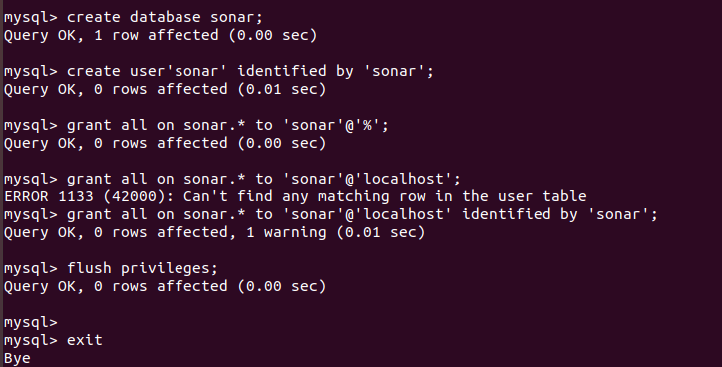

# cd sonarqube-5.6.7

# cd conf

# vi sonar.properties

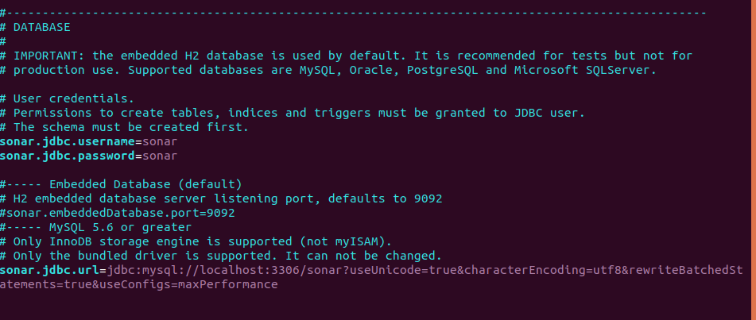
save & exit

# cd ../bin

# cd linux-x86-64

# ./sonar.sh start

- Install sonarqube scanner Plugin

- go to manage-jenkins------> systemconfiguration

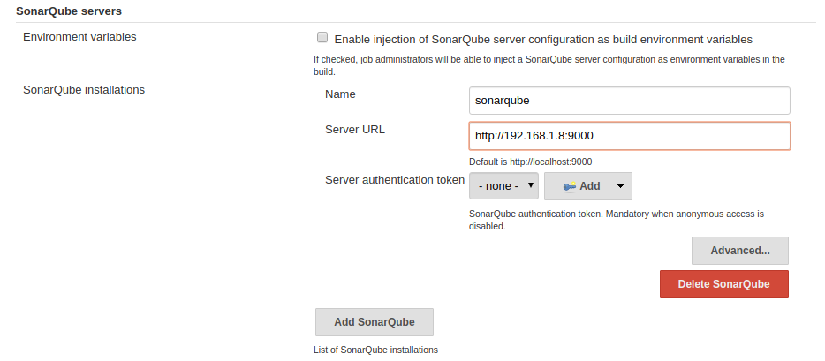

apply 7 save

- go to manage-jenkins-----------> global tool configuration

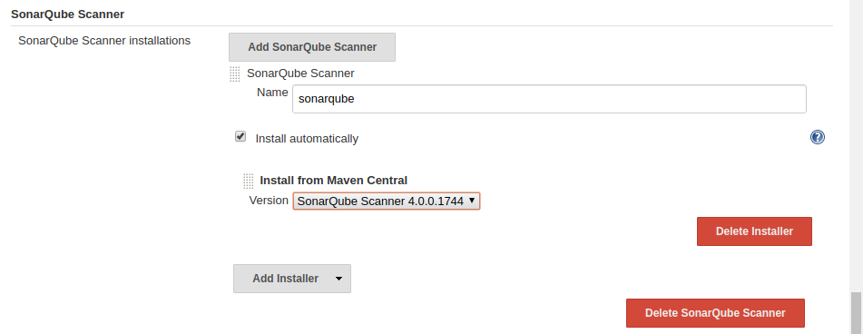
apply & save

Create a job

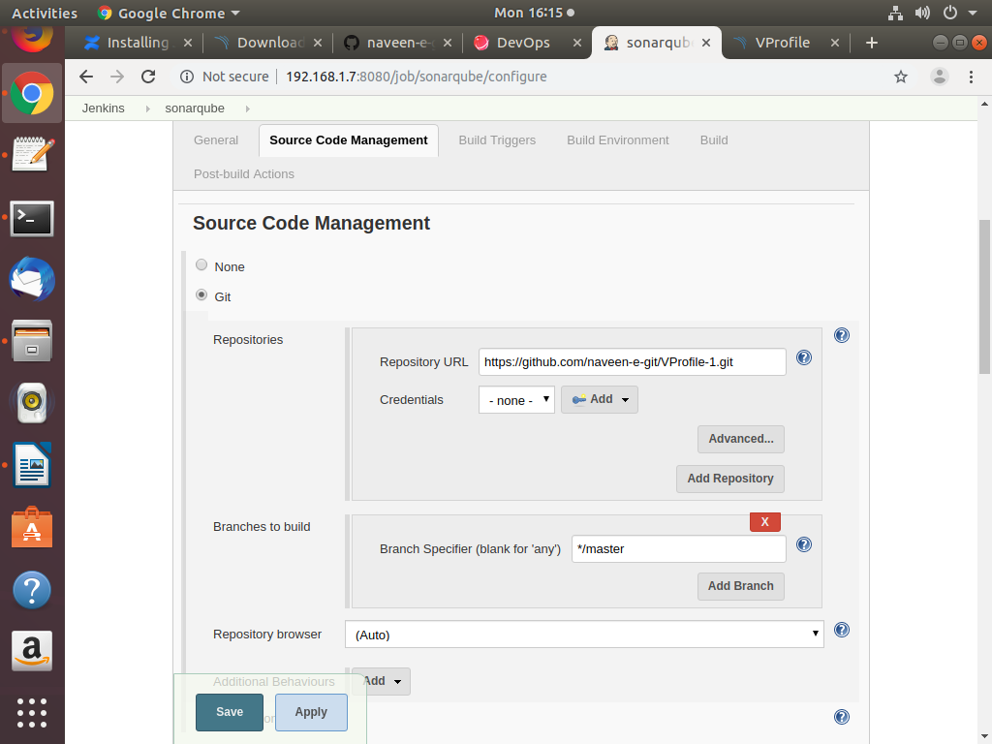

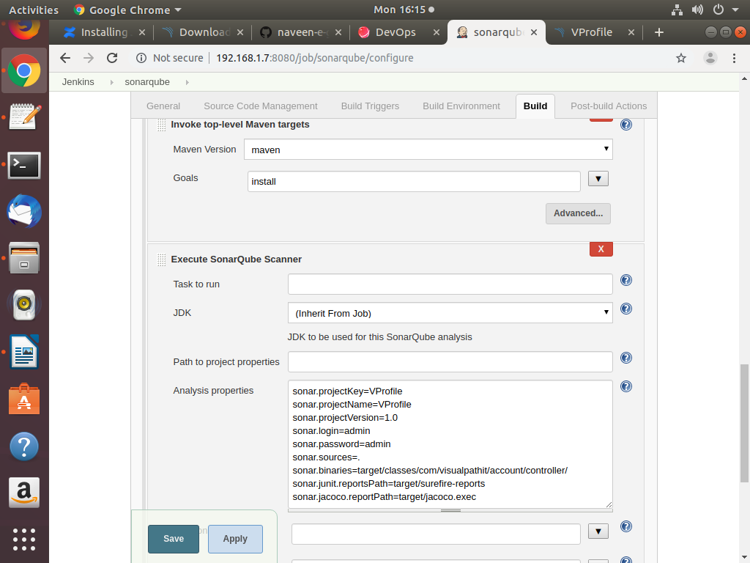

save & build now

after build got success,

hit the sonarqube server ip at browser

ex: http://192.168.1.8:9000

